NAME: SHYAM PATEL

ASSIGNMENT NAME: configure a development environment

SITE DESCRIPTION

My site will be of a college website where announcement will be made, upcoming events and also the school photo gallery. The visitors will be able to get information from the website.

VIRTUAL MACHINE

<http://patel1.centralus.cloudapp.azure.com/module1/index.html>

GIT HUB REPOSITORY

<https://github.com/shyam13/myProject>

Screenshots for environment set up

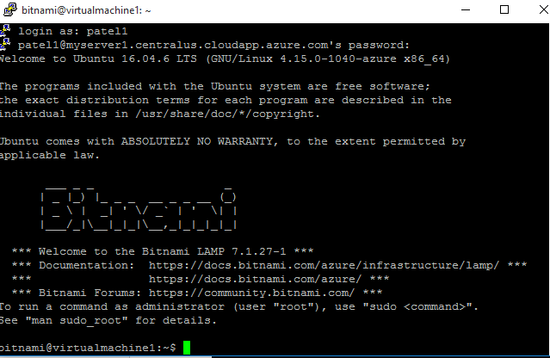

Putty configuration

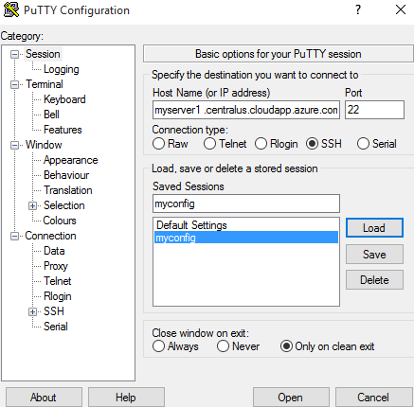

Git desktop

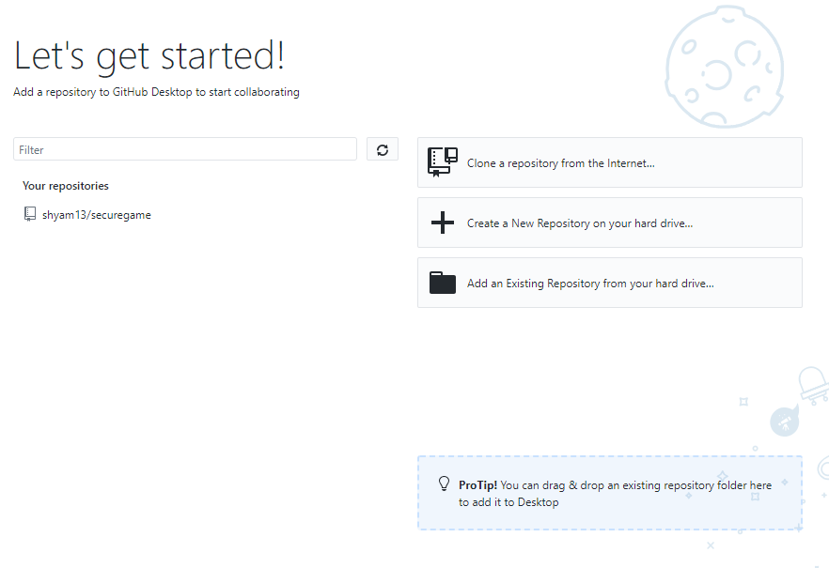

Atom

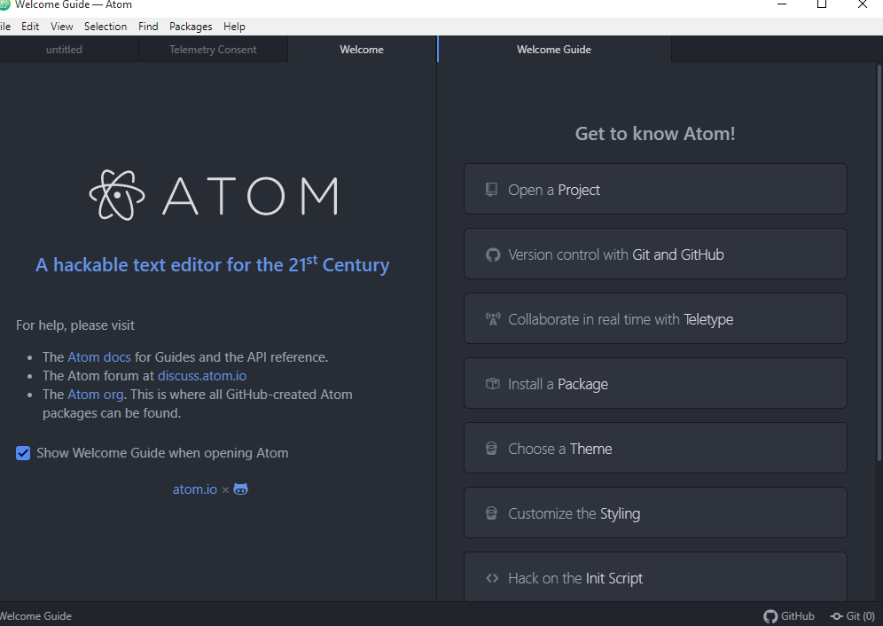

Virtual machine

